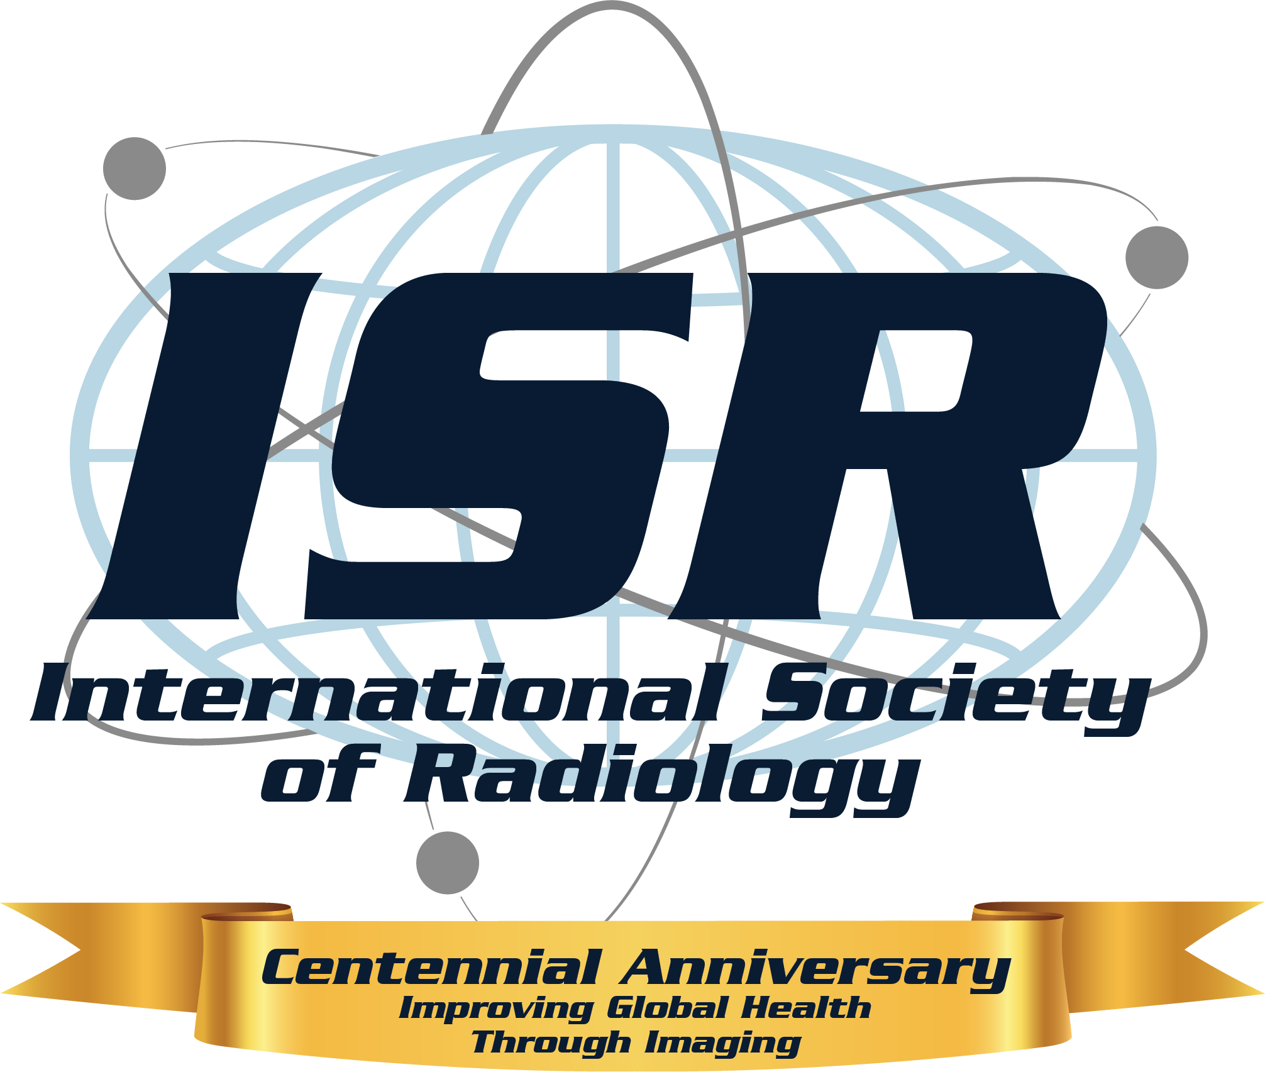

International Society of Radiology Honors Global Leader with Béclère Medal at ICR 2026
Cartagena, Colombia — May 14, 2026 — The International Society of Radiology (ISR) will honor one of the most influential figures in global medical imaging, Lluís Donoso-Bach, MD, PhD, with its highest distinction, the ISR Béclère Medal, during the ISR Centennial Celebration at the International Congress of Radiology (ICR) 2026 in Cartagena, Colombia.
Named in honor of radiology pioneer Antoine Béclère, the Béclère Medal is the ISR’s highest honor, recognizing extraordinary contributions to global radiology. As part of this recognition, Dr. Donoso-Bach will deliver the ISR Walter Fuchs Plenary Lecture at ICR 2026.
Dr. Donoso-Bach is widely recognized for his leadership in academic radiology, innovation in medical imaging, and commitment to advancing global health care strategy. He currently serves as president of the Foundation Món Clínic Barcelona and the Foundation España Salud, and as emeritus consultant at the Hospital Clínic Barcelona Research and Innovation Department. He is also director of the University of Barcelona–Siemens Healthcare Chair and a corresponding academic member of the Royal National Academy of Medicine of Spain.
Over a distinguished career spanning decades, Dr. Donoso-Bach has held key leadership roles, including Chairman of Radiology at UDIAT Diagnostic Centre and head of medical imaging at Hospital Clínic of Barcelona. His work has evolved from abdominal imaging and liver disease to pioneering efforts in digital imaging and the integration of information technology in radiology. Under his leadership, research teams developed patented technologies that are now widely implemented across Spain.
As an internationally respected leader, Dr. Donoso-Bach has served as president of the ISR, the European Society of Radiology, the Spanish Society of Medical Radiology, and the International Society for Strategic Studies in Radiology. He currently serves on the ISR Béclère-Fuchs Foundation Board of Directors. His contributions extend beyond imaging into global health policy through his work with The Lancet Commission on diagnostics and The Lancet Oncology Commission on medical imaging and nuclear medicine. He has authored more than 90 scientific publications and numerous book chapters, and his achievements have been recognized with multiple gold medals and honorary memberships from radiological societies worldwide.
Throughout his career, Dr. Donoso-Bach has demonstrated a commitment to advancing radiology through innovation, education, and international partnership. His contributions have strengthened the global radiology community and improved access to high-quality imaging worldwide.
“The ISR Béclère Medal recognizes individuals whose work has fundamentally shaped the field of radiology on a global scale,” said ISR President Bibb Allen Jr, MD, FACR. “Dr. Donoso-Bach exemplifies the vision, collaboration, and dedication that continue to move our profession forward.”
The award and plenary lecture will take place during ICR 2026, bringing together radiology leaders, clinicians, and researchers from around the world to share knowledge and advance the future of medical imaging.
About the International Society of Radiology
The International Society of Radiology is dedicated to advancing radiology education, promoting global collaboration, and improving access to medical imaging worldwide.

